TIMETABLE GENERATION

SYSTEM

### 

### A Project Work

*Submitted in the partial fulfillment for the award of the degree of*

# BACHELOR OF ENGINEERING

### IN

### COMPUTER SCIENCE

### (ARTIFICIAL INTELLIGENCE AND MACHINE LEARNING)

### Submitted by:

### ANIRUDH ROY

### 19BCS6136

### Under the Supervision of:

### Mr. Pramod Vishwakarma



# DEPARTMENT OF COMPUTER SCIENCE AND ENGINEERING APEX INSTITUE OF TECHNOLOGY

### CHANDIGARH UNIVERSITY, GHARUAN, MOHALI - 140413,

**PUNJAB**

#### MARCH & 2021

**Table of Contents**

Title Page i

Index ii

Declaration iii

Acknowledgement iv

List of Tables v

List of Figures vi

Timeline / Gantt Chart vii

**INTRODUCTION 8**

**LITERATURE SURVEY 9**

**PROBLEM FORMULATION 12**

**RESERCH OBJECTIVE 13**

**METHODOLOGY 14**

**PROPOSED MODEL 21**

**TENTATIVE CHAPTER PLAN FOR THE PROPOSED WORK 20**

**RESULT AND DISCUSSION 23**

**REFERENCES 25**

**DECLARATION**

I, **‘Anirudh Roy’**, student of **‘Bachelor of Engineering in Computer Science with Artificial Intelligence and Machine Learning’**, **session: 2019-2023**, Department of Computer Science and Engineering, Apex Institute of Technology, Chandigarh University, Punjab, hereby declare that the work presented in this Project Work entitled ‘**Timetable Generation System’** is the outcome of our own bona fide work and is correct to the best of our knowledge and this work has been undertaken taking care of Engineering Ethics. It contains no material previously published or written by another person nor material which has been accepted for the award of any other degree or diploma of the university or other institute of higher learning, except where due acknowledgment has been made in the text.

**(Anirudh Roy)**

**Candidate UID: 19BCS6136**

**Date: 28.04.2021**

**Place: Chandigarh**

iii

**ACKNOWLEDGEMENT**

I would like to express my special thanks of gratitude to my teacher Mr. Pramod Vishwakarma, who gave me the golden opportunity to do this wonderful project “**Time Table Generation System”**.

Who also helped me in completing my project, I came to know about so many new things during this project, I am really thankful to them.

Secondly, I would also like to thank my parents and friends who helped me a lot in finalizing this project and also my team for completing this project within limited time frame.

**Date:28/04/2021 Anirudh Roy**

**Place: Chandigarh 19BCS6136**

**Group - 8**

iv

***List of Tables***

##### Table Title page

***1.1*** *Gantt Chart v*

***2.1*** *Literature review summary 9*

v

***List of Figures***

##### Figure Title page

1. *A Timetable Generation Flow Diagram 13*
2. *Insertion Module diagram for Time table scheduler 14*
3. *Allocation Module diagram for Time table scheduler 14*
4. *Display Module diagram for Time table scheduler 15*
5. *Diagram for flow of the complete Time Table Generator model 21*
6. *Snapshots of the executable file 23*

vi

# *Timeline / Gantt Chart*

|  |  |  |  |  |  |
| --- | --- | --- | --- | --- | --- |
|  | **FEBRUARY 2021**  **(Second-Third Week)** | **MARCH 2021**  **(First-Second Week)** | **MARCH 2021**  **(Third-Fourth Week)** | **APRIL 2021**  **(First-Second Week)** | **APRIL 2021**  **(Third-Fourth Week)** |
| **Proposal of project** |  |  |  |  |  |
| **Research** |  |  |  |  |  |
| **Synopsis** |  |  |  |  |  |
| **Project Modelling** |  |  |  |  |  |
| **Implementation** |  |  |  |  |  |
| **Testing/Debugging** |  |  |  |  |  |
| **Project Presentation/Assessment** |  |  |  |  |  |

vii

**1. INTRODUCTION**

Even though most college administrative work has been computerized, the lecture timetable scheduling is still mostly done manually due to its inherent difficulties. The manual lecture timetable scheduling demands considerable time and efforts. The lecture-timetable scheduling is a Constraint satisfaction problem in which we find a solution that satisfies the given set of constraints. Automatic Timetable Generator is a JavaFx based software used to generate timetable automatically. Currently timetable is managed manually. It will help to manage all the periods automatically. It Maximum and minimum work load for a Faculty for a day and week will be specified for the efficient generation of timetable. Timetable Scheduler targets to develop software for college in order to handle the ‘Timetable Formation’ for the staff. The head of every Department has problem in delegating work to their subordinates and response for the work position. This work resolves the problem by permitting the lectures to see their assigned subject and timetable. This software helps to handle the particulars of the timetable of staff. JavaFx is employed as front end which is used to craft the user interface. MySQL is employed as back end and used to craft the database and save the particulars. Anybody with a little computer knowledge can approach and deal with the software with ease; hence it can be termed user friendly. Hence it offers security to the users by offering perfect login. The process of preparing a timetable involves beneficial employment of resources which needs to be confronted each year by every educational institute. Most colleges have a number of different courses and each course has a number of subjects. Now there are limited faculties, each faculty teaching more than one subjects. So now the time table needed to schedule the faculty at provided time slots in such a way that their timings do not overlap and the time table schedule makes best use of all faculty subject demands. This object comprises of Classroom objects and the timetable for every it likewise a fitness score for the timetable. Fitness score relates to the quantity of crashes the timetable has regarding alternate calendars for different classes. Classroom object comprises of week objects. Week objects comprise of days, comprises of timeslots. Timeslot has an address in which a subject, student gathering going to the address and educator showing the subject is related.

Timetable Generation System generates timetable for each class and teacher, in keeping with the availability calendar of teachers, availability and capacity of physical resources (such as classrooms, laboratories and computer room) and rules applicable at different classes, semesters, teachers and subject level. Best of all, this Timetable Generation System tremendously improves resource utilization and optimization.

Therefore, we are proposing a system for Automatic timetable generation. The algorithm-based application allots periods in such a way that no period clashing or faculty period clash is met. The subjects are paired in such a way that teachers remain associated and no period clash appears. Subjects are allotted as per priority based on the number of lectures per week of that subject. High priority subjects are given preference for number of periods per week and are allotted accordingly. Also, the corresponding labs are allotted for the suitable day. This helps satisfy the constraint of number of subjects per day both theory and lab for a faculty. This procedure creates not only a feasible Time-Table for the department but also an optimal one. Output of the application is not only the class time table but also faculty timetable, both the optimum ones.

**2. LITERATURE REVIEW**

There exist various problems such as Sports Timetabling, Examination Timetabling, Employee Timetabling and university timetabling. Carter and Laporte (1998) considered different categories to solve the timetabling problem. They are – Cluster method, Sequential method, Meta-Heuristics and Constraint Based method. Meta Heuristics is a higher-level procedure which is used to provide good enough solutions for optimization problems. On some class of problems, they do not guarantee a globally optimum solution. This method is used when the classical methods are too slow or fail to give a solution. This is achieved at the cost of optimality and precision for speed.

Genetic Algorithms (GA) was invented by John Holland and has described this idea in his book “Adaptation in natural and artificial systems” in the year 1975. Genetic Algorithms are inspired by Darwin’s evolutionary theory. GA comes under the class of Evolutionary algorithms that use the principle of natural selection to derive a set of solutions towards the optimal solution. It is a search heuristic which generates solutions to optimization problems using techniques inspired by natural evolution like mutation, inheritance, crossover and selection. Here the algorithm is generally started with a set of candidate solutions called the population. Each solution in the initial population has a set of characteristics (its chromosomes or genotypes) which can be altered and mutated. Solutions from one population are taken and used to make another population, with a hope that the new population will be better than the old one. Solutions are selected for breeding on the basis of their fitness. The fitness function usually identifies the number of constraints violated by a timetable.

A timetable is said to be more fit if it violates less number of constraints. In the timetable generation problem, the population is a set of timetables maintained in memory. Each timetable is evaluated by finding the number of times it violates the constraints. Each timetable has an equal chance to participate in breeding. Bhaduri, an evolutionary technique has been used to solve the time table scheduling problem. Methodologies like Genetic Algorithms (GAs), Evolutionary Algorithms (EAs) etc, have been used with mixed success.

This project system is able to generate time tables in completely automated way which will save a lot of time and effort of an institute administration. This timetable system is generic so that we can work equally well for different School, Colleges and Universities. It Focus on optimization of resources i.e. teachers, labs and rooms, time slots, credits etc. The system will have well designed database to store all the information which will be entered in as the input. Separate database maintaining basic information, subjects, teachers, batches and their associations and other details Database for holding generated timetable and for storing required timetables.

The system will have algorithms to process all the data present in the database and keeping in view the various constraints like that a teacher should not have two consecutive lectures/labs, students have minimum one-hour gaps, proper rooms are allocated for the lectures and tutorials, labs are used optimally so that they are used for the maximum possible time, it will generate the time table.

Modules:

It has developed in three modules:

* Insertion Module
* Allocation module
* Display module comparisons.

**Literature Review Summary**

Table 2.1: Literature review summary

|  |  |  |  |  |  |
| --- | --- | --- | --- | --- | --- |
| **Year and citation** | **Purpose of study** | **Granularity Level** | **Type of vulnerabilities** | **Data Set** | **Evaluation parameters** |
| 2017 | The goal was to identify the issues that were important to evaluate user satisfaction with automated timetable generator. | Is automatic time-table generator efficient | To generate the timetable without logical errors. | No. of subjects and faculty list. | Resemblance of the final output with their objective. |

# 3. PROBLEM FORMULATION

Avoid the complexity of setting and managing timetables manually. It will help you to manage all the periods automatically. Faculty can receive their period's information on their screen. Initially, we will be setting the maximum workloads for a Faculty in a day, week, and month. The main challenge is to manage the timetable when credits are defined with respect to students as well as the teachers teaching that subject.

The quality of the content (both semantic and syntactic) could be compromised if

errors creep in.

* The login criteria could be violated; i.e., every login must create a session which will

expire after a certain time of inactivity. If this fails, this would be a major security

breach.

* Process of going from index -> teacher_panel -> class_panel -> table_generate_panel is

a transaction. So, all the ACID properties of transaction must be ensured.

* The navigation constraints should be uniformly implemented.
* The user cannot go back or refresh the webpage once the generation of timetable process has begun.
* The sequence of the time-table generation process should not be violated or else

the generated time table might be faulty.

* The algorithm (logic) could be faulty or falsely implemented.
* The number of entities to be generated in the dropdown must be precise and accurate

or else the whole generation would be rendered useless.

* The web application may have errors while hosting the server.

# 4. RESEARCH OBJECTIVE

The proposed research is aimed to carry out work leading to the development of an approach for time-table generation system. The proposed aim will be achieved by dividing the work into following objectives:

1. To reduce the time required for generating time table than existing system.

2. To increase efficiency and accuracy of proposed system.

3. To reduce paper and labor work.

4. The first activity in software project planning is the determination of software scope.

5. The second software planning task is estimation of the resources.

6. Storing the data in database

7. Creating a User Interface

8. Coding for Interface

9. Testing the project

# 5. METHODOLOGY

The following methodology will be followed to achieve the objectives defined for proposed research work:

1. **Detailed study of Time Table Generation System will be done.**

The establishment and use of sound engineering principles in order to obtain economically developed software that is reliable and works efficiently on real machines is called software engineering. Software engineering is the discipline whose aim is:

➢ Production of quality software

➢ software that is delivered on time

➢ cost within the budget

➢ satisfies all requirements.

Software process is the way in which we produce the software. Apart from hiring smart, knowledgeable engineers and buying the latest development tools, effective software development process is also needed, so that engineers can systematically use the best technical and managerial practices to successfully complete their projects. A software life cycle is the series of identifiable stages that a software product undergoes during its lifetime. A software lifecycle model is a descriptive and diagrammatic representation of the software life cycle. A life cycle model represents all the activities required to make a software product transit through its lifecycle phases. It also captures the order in which these activities are to be taken.

Among the various life cycle, following is one of a type

Prototype Model

• Since in this methodology a working model of the system is provided, the users get a better understanding of the system being developed.

• Errors can be detected much earlier.

• Quicker user feedback is available leading to better solutions.

• Missing functionality can be identified easily Confusing or difficult function can be identified requirements validation, Quick implementation, incomplete but functional, application. Automatic Timetable Generator is a creative and scientific system through which colleges and other institutions can easily handle timetable management.

The final system should able to generate time tables in completely automated way which will save a lot of time and effort of an institute administration. To make a timetable system generic so that I can work equally well for different School, Colleges and Universities. User defined constraints handling. Ease of use for user of system so that he/she can make automatic time table. Focus on optimization of resources i.e. teachers, labs and rooms etc. Provide a facility for everyone to view timetable. Generate multiple useful views from time table.

Outcomes depends on

1. Interface for input

The system will be having an easy to use and interactive interface to enter all the inputs like the teacher name, the data for the rooms and data for the labs and the database for subject.

1. Database Capabilities

The system will have well designed database to store all the information which will be entered in as the input. Separate database maintaining basic information, subjects, teachers, batches and their associations and other details Database for holding generated timetable and for storing required timetables.

1. Processing Capabilities

The system will have algorithms to process all the data present in the database and keeping in view the various constraints like that a teacher should not have two consecutive lectures/labs, students have minimum one-hour gaps, proper classes of the specific stream are allocated for the lectures and tutorials, labs are used optimally so that they are used for the maximum possible time, it will generate the time table.

1. System Architecture

Further to the study of data flow in timetable production, we are able to propose architecture for implementing the system.

1. Architecture for Timetable Production

Abstractly speaking, software architecture describes the elements of a system. It also shows the interactions between these elements, the models governing its composition and the constraints of these models. Generally, when facing a complex problem, the best approach is to break it down into parts that become easier to solve with simple solutions. Then, when we combine all these small solutions, we can find the solution to our complex problem.

1. Flow Chart of Time Table Scheduling Process

A flowchart is a type of diagram that represents an algorithm, workflow or process, showing the steps as boxes of various kinds, and their order by connecting them with arrows. This diagrammatic representation illustrates a solution model to a given problem as in Fig.1

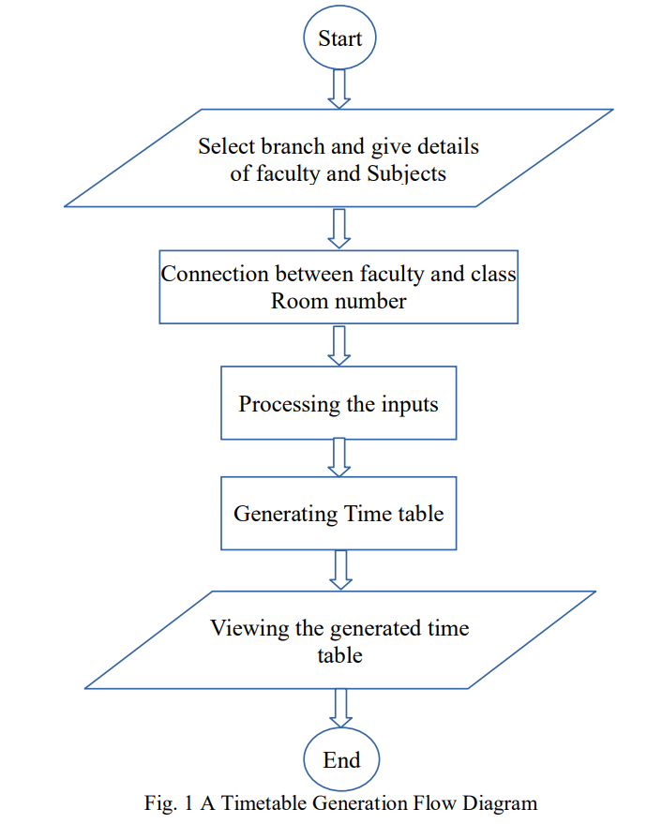

1. Modules It has developed in three modules

• Insertion Module

• Allocation module

• Display module

1. Insertion Module In this module we provide various user inputs to our system which acts raw data for creating the final time table Fig. 2

•Faculty Details

In this sub module we insert various details of faculty such as faculty name, email and contact number. And we also provide a unique faculty id which helps in referencing throughout our software and it also acts a login credentials or as we call it, the admin.

•Subject Details

In this sub module we insert details of subjects that are in our curriculum such and subject name. We try to store the theory subjects and lab subjects separately in our database so that it becomes easy for us in future use.

•Mapping

In this sub module we take user input such as which faculty is taking which theory subjects and which lab in a particular semester and we store it our database.

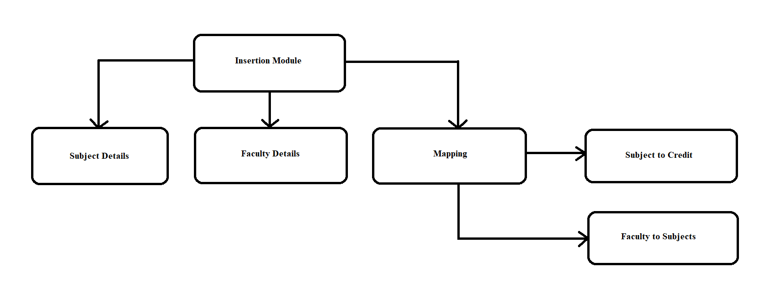

Fig. 2 Insertion Module diagram for Time table scheduler

1. Allocation Module.

In this module, user can choose any semester randomly to start the process. He starts filling the slots from the Monday by selecting the particular stream, faculty that is mapped with that stream gets allotted to that slot of the day. The various soft and hard constraints are checked every time the slot is filled. It will not be blocked if any of the constraints is not satisfying. We are checking all these constraints by writing query in stored procedure and using the database data. Fig. 3

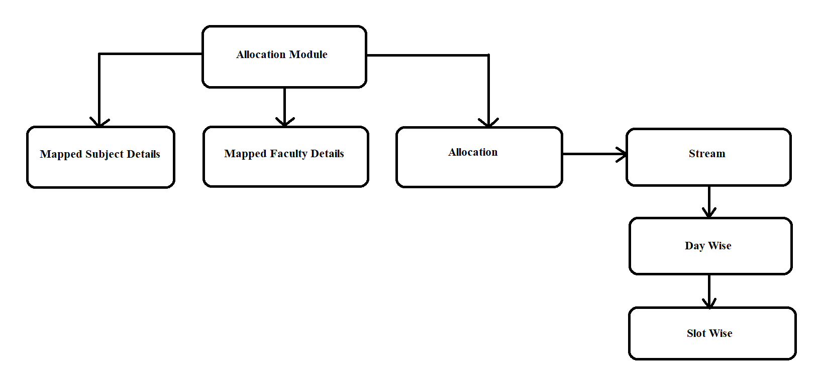

Fig. 3 Allocation Module diagram for Time table scheduler

1. Display Module

In this module we can view how the time table is generated of each class. We have also provided the feature to view the class time table and faculty wise time table Fig 4

• Student Time Table

In this we can view the class wise generated time table by selecting the particular stream which we want to see. The time table will have subject with faculty who handling that subject.

• Teacher/Faculty Time Table

In this we can view all the subject name that are handled by a particular faculty.

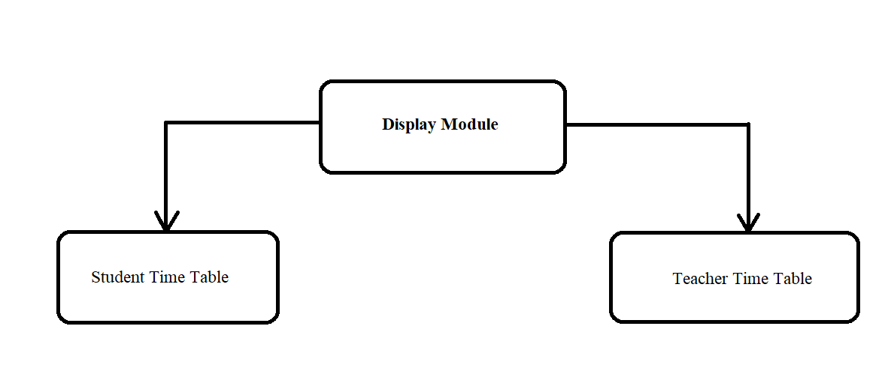

Fig. 4 Display Module diagram for Time table scheduler

1. **Installation and hand on experience on existing approaches of Time Table Generation System will be done. Relative pros and cons will be identified.**

**Project implementation:**

The Project is loaded in IntelliJ IDEA 2019/Eclipse. We used it for Design and coding of project. Created and maintained all databases into SQL Server 2008, in that we create tables, write query for store data or record of project.

1. Hardware Requirements:-   
    1. Core i3 Processor Based Computer   
    2. 1 GB-RAM   
    3. 50 GB Hard Disk
2. Software Requirements:-
3. Windows 7 or higher
4. IntelliJ IDEA 2019/Eclipse.
5. SQL Server 2008.

**Existing System:**

In the existing system, each task is carried out manually and processing is a very tedious job. The Organization is not able to achieve its need in time and the results too may not be accurate. Due to all the manual maintenance, there are number of difficulties and drawbacks that exist in this system.

**Drawbacks of the Existing System:**

* Increased transaction leads to the increased source document and hence maintenance becomes difficult.
* If any student or staff entry is wrongly made then the maintenance becomes very difficult.\

**Proposed System:**

The proposed system is designed to be more efficient than the actual manual system. It invokes all base tasks that are now carried out manually, such as the forms transactions and reports which is added advantage.

**Advantages:**

* Faculty need not worry for time clashes.
* Authority now does not need to perform permutation and combination
* Authority can concentrate on other things rather than wasting their time on preparing Time-Table.
* Gives accurate information
* Simplifies the manual work
* It minimizes the documentation related work
* Provides up to date information.

1. **Various parameters will be identified to evaluate the proposed system.**

**Input Parameters:**

**For Student:**

* Stream
* Number of slots
* Number of days
* Break timing

And the rest from the database which is as follows

* Number of subjects
* List of subjects
* Credits

**For Faculty:**

* Teacher Name
* Subject

And the rest from another database which is as follows

* List of subjects
* With associated credit
* Stream’s belonging to the specific subject

And lastly, the time table will be processed with the above said inputs, and it will be displayed on the screen.

1. **Comparison of new implemented approach with existing approaches will be done.**

Time Table creation is exhausting and time-consuming process for the faculty in charge. At present this is done manually as there are no efficient time table generators. While framing time table the basic problems are slot clashes. Allotting periods itself is so tedious that allotting the whole timetable is not at all efficient when done manually. So, even the software which has already been created does not comply with the constraints. The present system is therefore time consuming, tedious process requiring manual labor and simultaneously, having less flexibility. Therefore, we are proposing a system for Automatic timetable generation. The algorithm-based application allots periods (theory as well as labs) in such a way that no period clashing or faculty period clash is met. The subjects are paired in such a way that teachers remain associated and no period clash appears. Subjects are allotted as per priority based on the number of lectures per week of that subject. High priority subjects are given preference for number of periods per week and are allotted accordingly. Also, the corresponding labs are allotted for the suitable day. This helps satisfy the constraint of number of subjects per day both theory and lab for a faculty. We assign subjects to teacher as per their seniority and as per their preference. This is done starting from the high priority subject first and then the decreasing priority subjects and then the unassigned subjects. This keeps utmost care of the designation of faculties and their p. This procedure creates not only a feasible Time-Table for the department but also an optimal one. Output of the application is not only the class time table but also faculty timetable, both the optimum ones. The proposed system is based on an algorithm that takes values and manages the constraints and resource scheduling one by one. The system generates a timetable for the lecture courses as well as the staff timetable. It distributes workload of lectures equally among all the specified time slots. It prioritizes the lectures according to customized antecedence. If lecture cannot be adjusted then it can be moved up in higher priority slot until adjusted accordingly.

**6. PROPOSED MODEL**

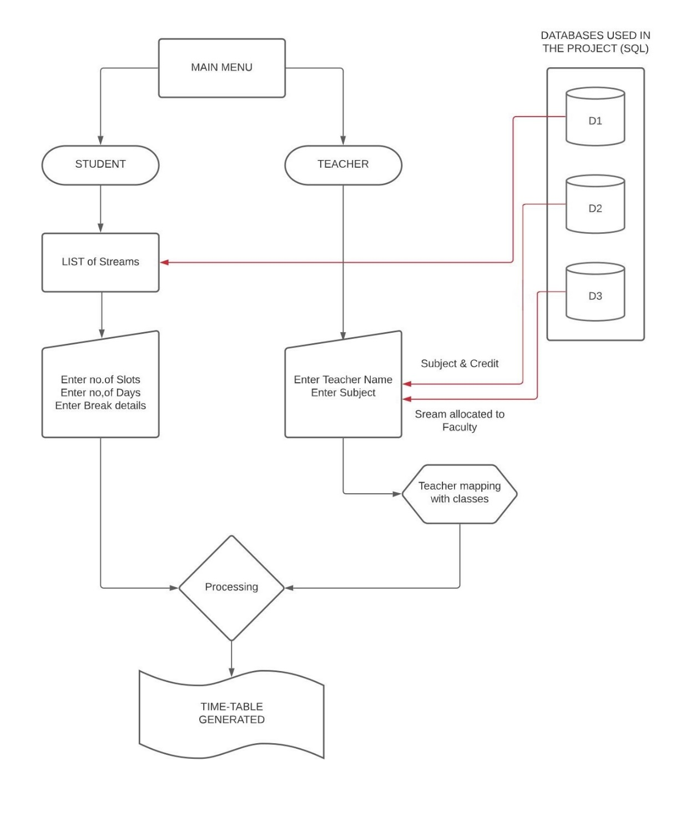

Fig. 5 Diagram for flow of the complete Time Table Generator model

This system architecture explains the organization of “Timetable generation system”. The proposed system is designed to be more efficient than actual manual system. It is a combinational project working with real-time database and processing them with other inputs to generate a best schedule for the user.

**7. TENTATIVE CHAPTER PLAN FOR THE PROPOSED WORK**

#### CHAPTER 1: INTRODUCTION

This chapter will cover the overview of our project Timetable Generation System.

#### CHAPTER 2: LITERATURE REVIEW

This chapter include the literature available for Automatic Timetable Generator. The findings of the researchers will be highlighted which will become basis of current implementation.

#### CHAPTER 2: BACKGROUND OF PROPOSED METHOD

This chapter will provide introduction to the concepts which are necessary to understand the proposed system.

#### CHAPTER 4: METHODOLOGY

This chapter will cover the technical details of the proposed approach.

#### CHAPTER 5: EXPERIMENTAL SETUP

This chapter will provide information about the subject system and tools used for evaluation of proposed method.

#### CHAPTER 6: RESULTS AND DISCUSSION

The result of proposed technique will be discussed in this chapter.

#### CHAPTER 7: CONCLUSION AND FUTURE SCOPE

The major finding of the work will be presented in this chapter. Also, directions for extending the current study will be discussed.

#### RESULT AND CONCLUSION

#### PUBLICATIONS (Optional)

**REFERENCES**

**8. RESULT AND CONCLUSION**

Snapshots of the project with labels

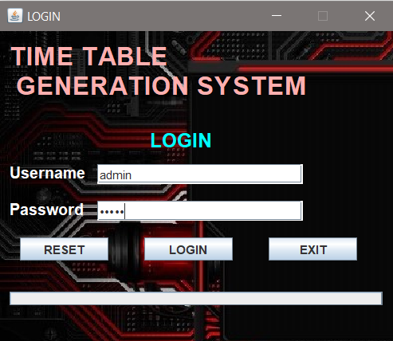 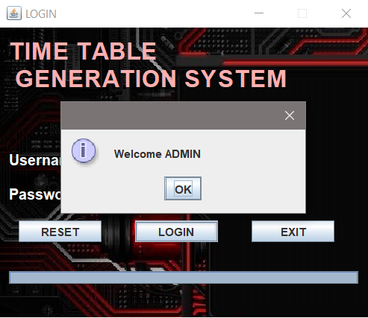

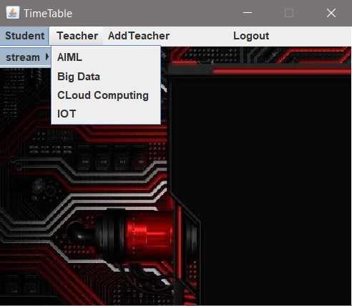 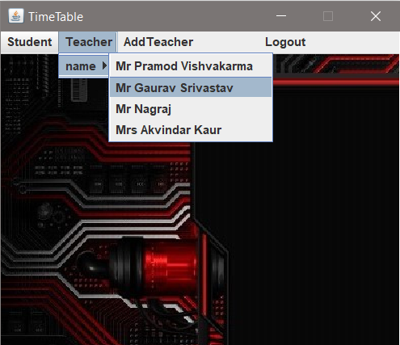

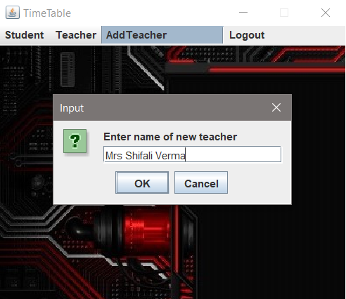

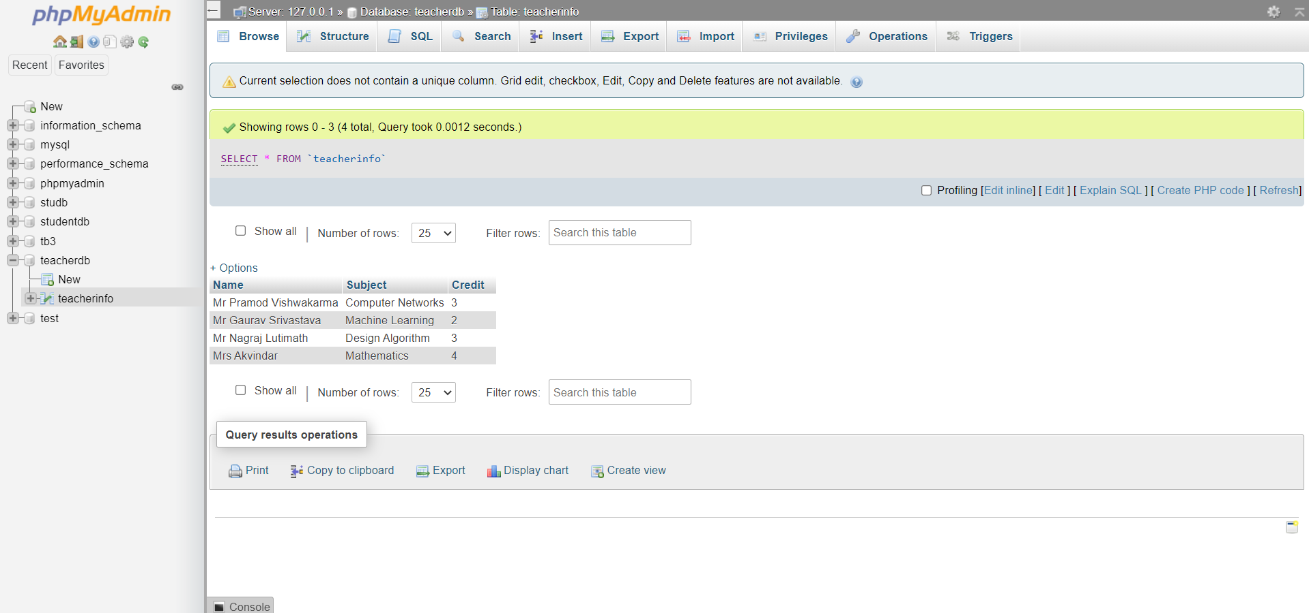

Database 1

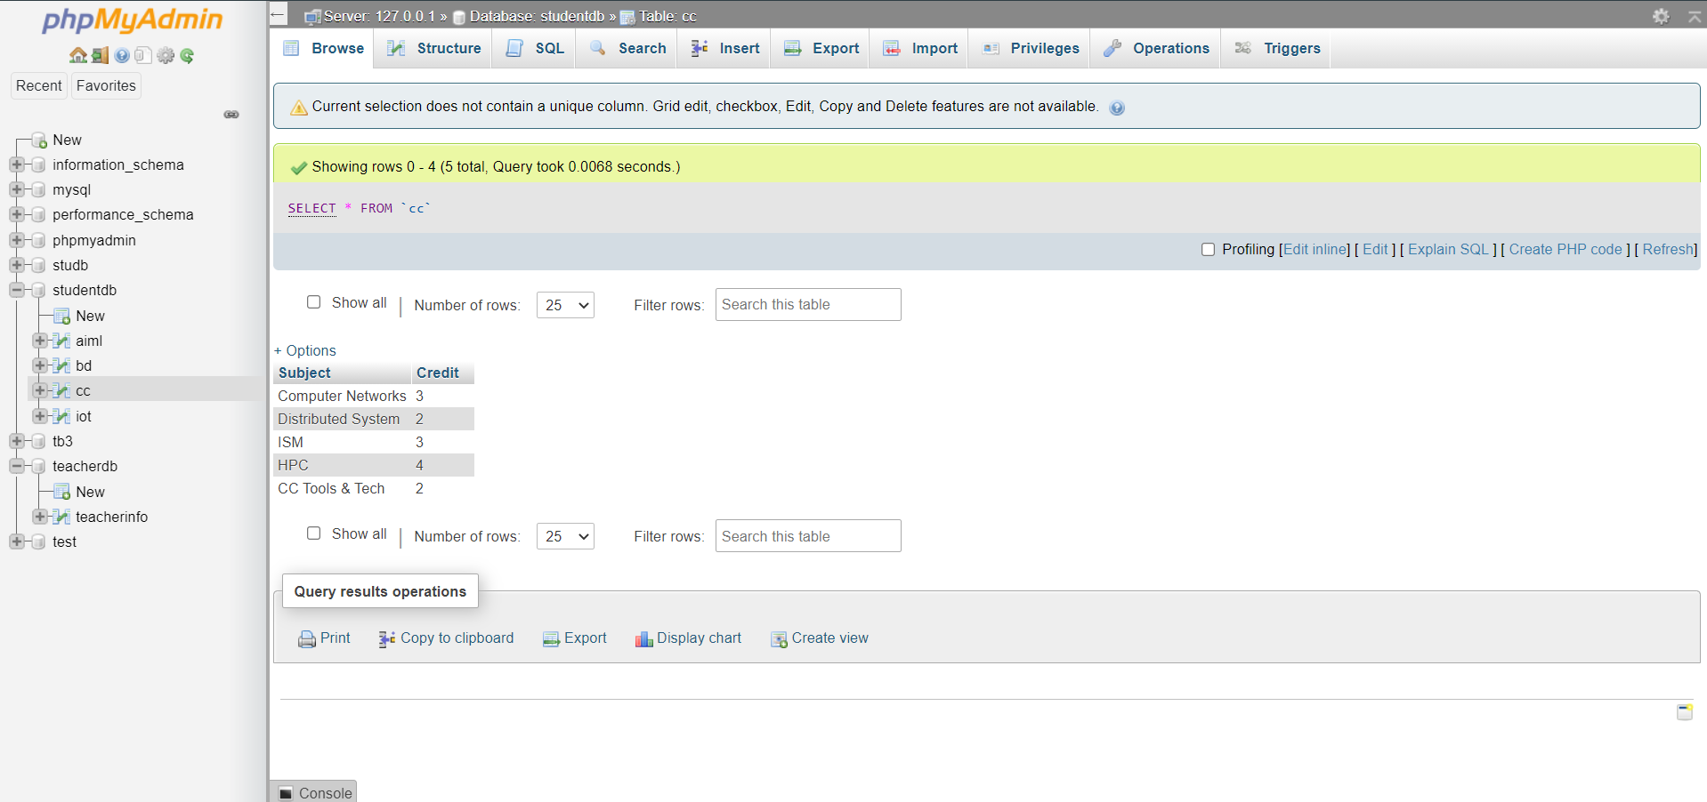

Database 2

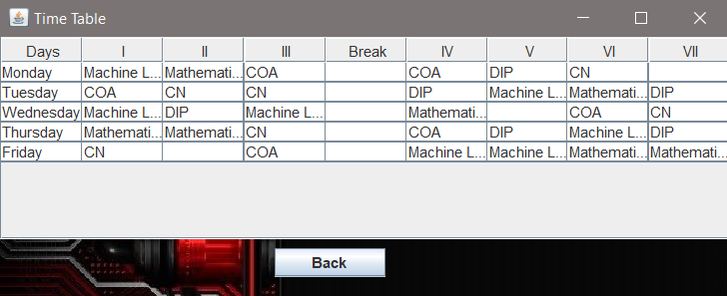

Conclusion: Student Time-table was generated.

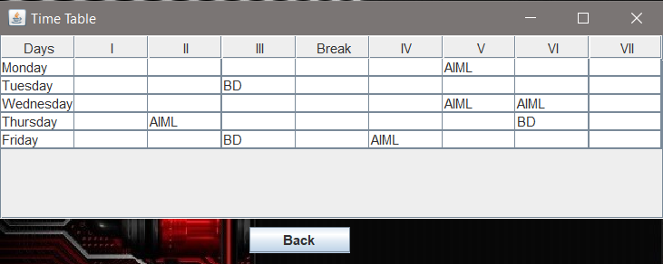

Conclusion: Teacher Time-table was generated.

**9. REFERENCES**

1. Albert Cliai Meng l‟att, Chia Wee Kee, Lee Chee Heong, Ng How Seng, Karen Ng Sor Har, Puah Suet Ni, Alvis Yeo Kok Yong, Mark Yeo Soon Hock, and Edmond C. Prakash, “SOFTWARE ENGINEERING APPROACH FOR A TIMETABLE GENERATQR”, (2000).
2. Asif Ansari, and Prof Sachin Bojewar, “Genetic Algorithm to Generate the Automatic Time-Table – An Over View”, (2014).
3. http://www.ijarcsse.com
4. http://ieeexplore.ieee.org/xpl/articleDetails.jsp?tp=&arnu mber=870307&queryText%3DAutomated+Timetable+Generation